Lesson Goals:
-To make chemistry interesting. -To use experiments to make and test predictions.
-To do an experiment in English. -To understand how concentration changes rate.

Prediction:
What do you think will happen?
When concentration _____________, the rate of reaction will _____________.
___________________________________________________________________________

Preparation:
Equipment:
-Two 100mL Beakers -Four 100mL Conical Beakers -Two 10mL Metric Glasses
-One 50mL Measuring Cylinder -One 2mL Pipette -One Stopwatch
Reagents:
-Solution A -Solution B -Distilled Water -Starch Solution

Method:
- In each of three 100mL Conical Beakers, add the following:
 | Add… | Of… | Using…
A1 | 5mL | Solution A | 10mL Metric Glass
 | 15mL | Distilled Water | 50mL Measuring Cylinder
 | 2mL | Starch Solution | 2mL Pipette
A2 | 10mL | Solution A | 10mL Metric Glass
 | 10mL | Distilled Water | 50mL Measuring Cylinder
 | 2mL | Starch Solution | 2mL Pipette
A3 | 15mL | Solution A | 10mL Metric Glass
 | 5mL | Distilled Water | 50mL Measuring Cylinder
 | 2mL | Starch Solution | 2mL Pipette

- Measure 10mL of Solution B with a 10mL Metric Glass.
- Add the B to A1 and time the reaction with the stopwatch.
- Repeat steps ② and ③ for A2 and A3.

Results:
Record the reaction times below.
 | Volume of A (mL) | Reaction Time (s)
A1 + B | 5
A2 + B | 10
A3 + B | 15
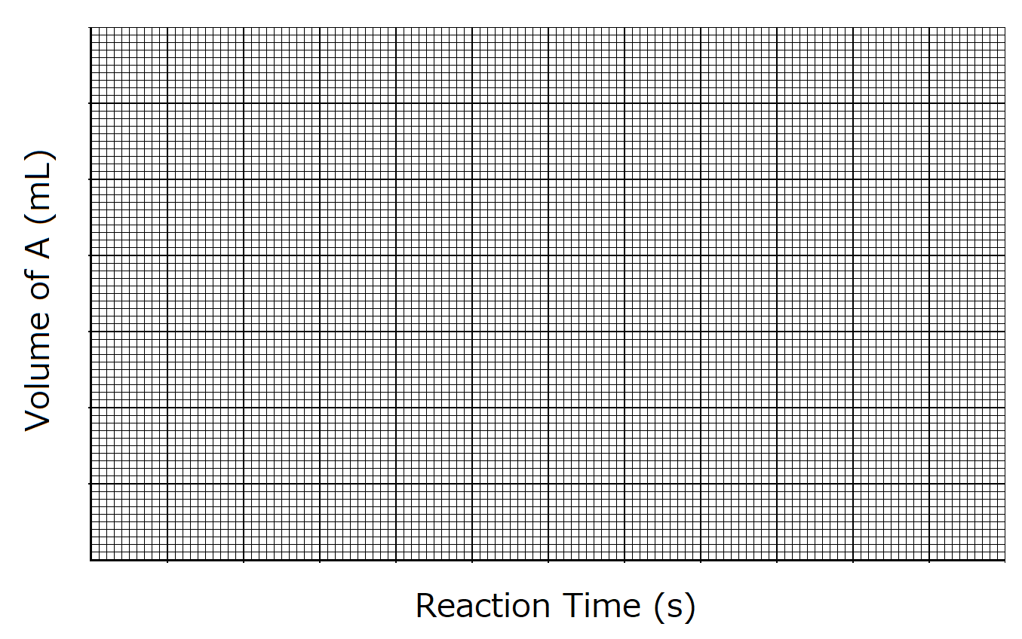
-Did the results match your prediction?
Yes/No, _______________________________________________________________________________

Challenge:
-Try to make a solution that changes colour in exactly ____ seconds!
Volume of Solution A | Volume of Distilled Water | Reaction Time
___ mL | ___ mL | ___ s

Conclusions:
- When concentration _____________, the rate of reaction _____________.
- If concentration doubles, the rate of reaction _____________.
- We can see the rate of reaction from the ____________ of the graph.

Koyo High School 1st Year, Class ( ), Number ( ) – Name ( )

